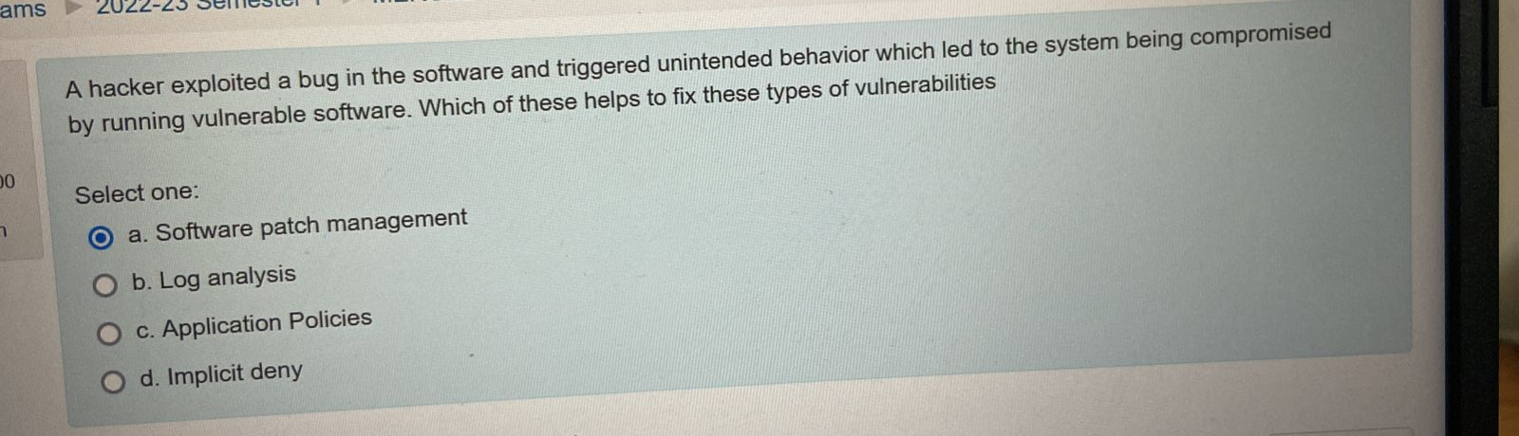

A . Software patch management

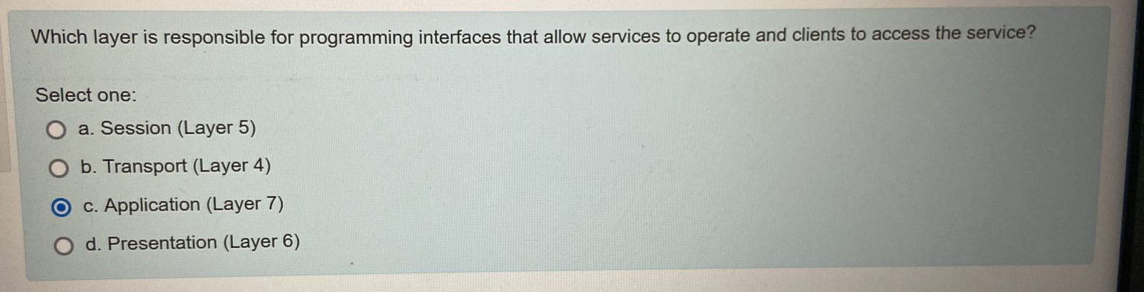

C.Application(Layer 7)

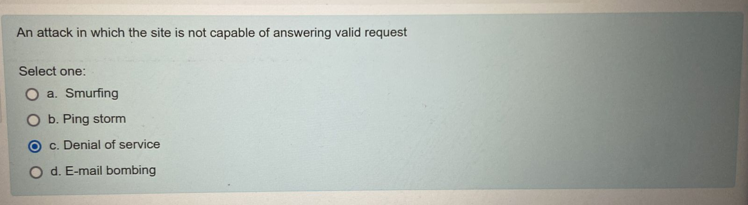

C. Denial of service.

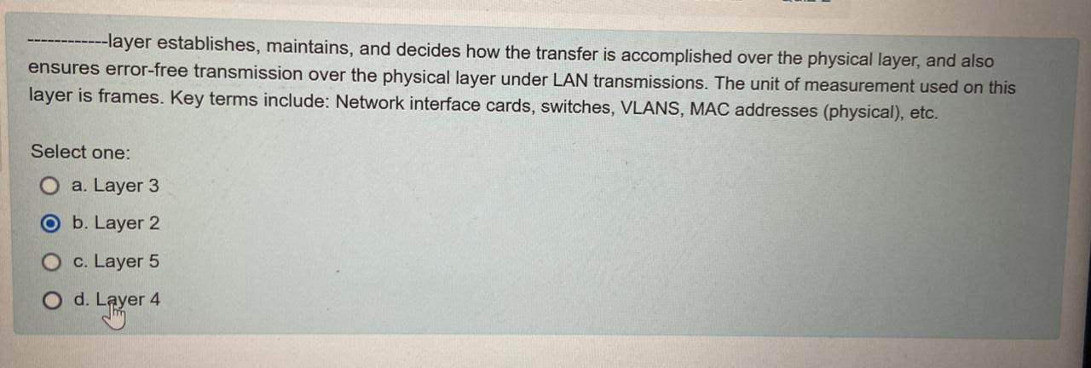

b. Layer2

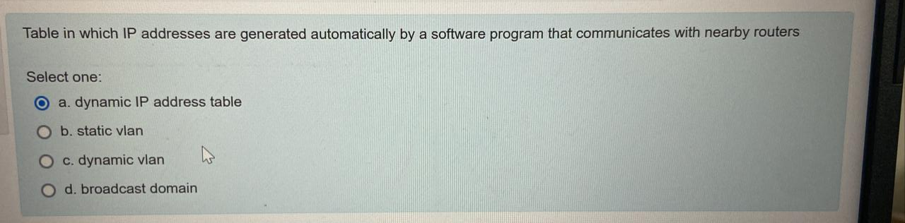

1. Dynamic IP address table

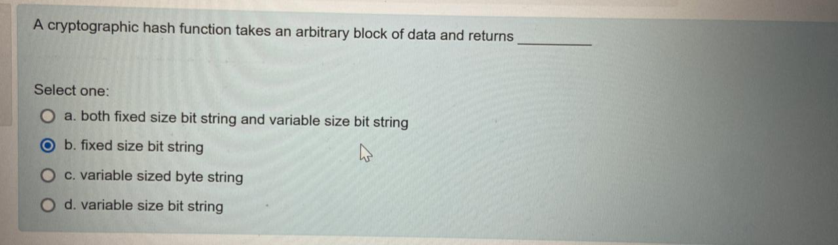

B:Fixed size bit string

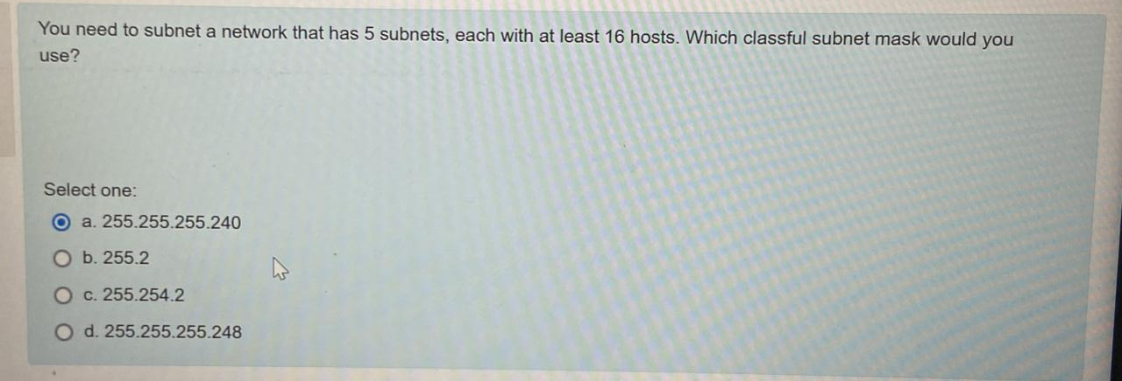

255.255.255.224

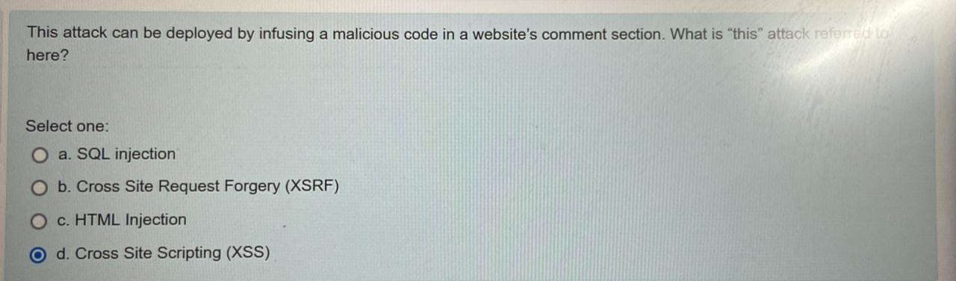

ANS : Cross site scripting

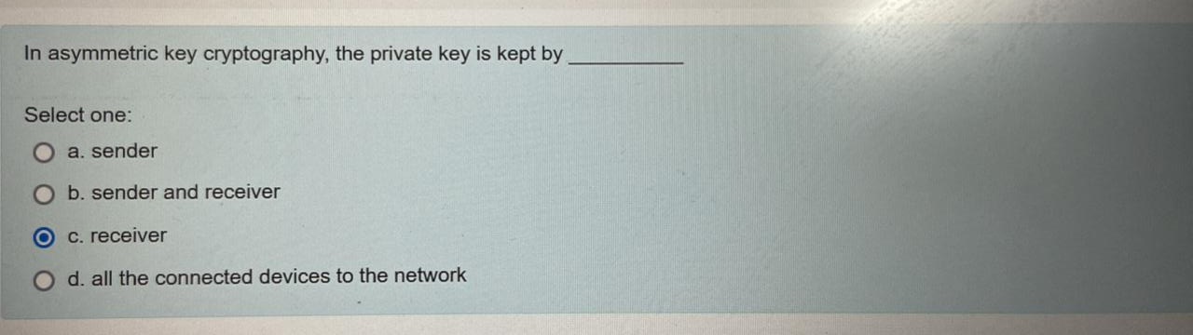

Receiver.

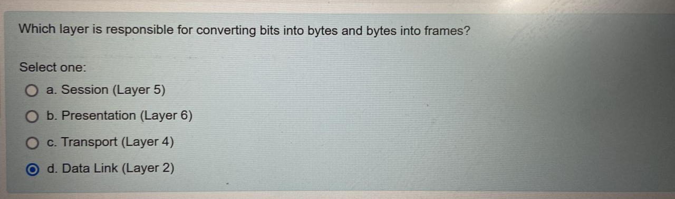

D DataLink

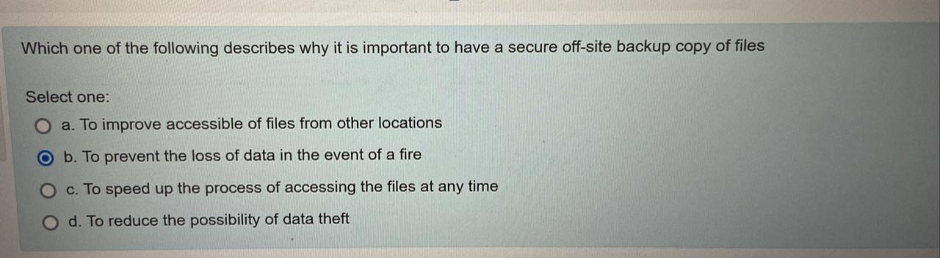

Ans : b

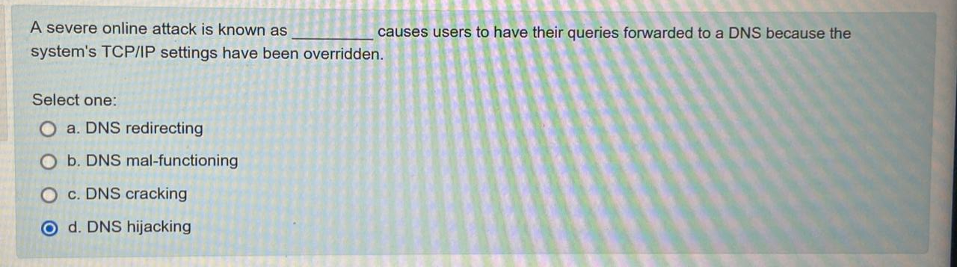

d) DNS hijacking

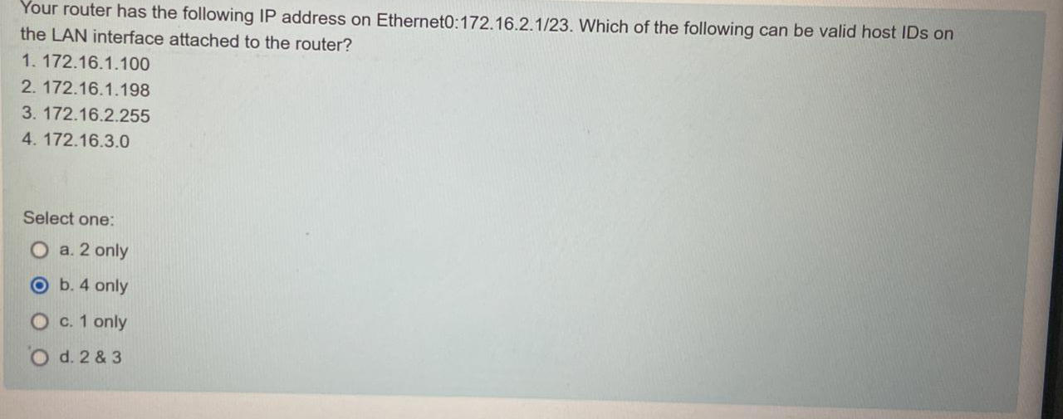

3 and 4 only

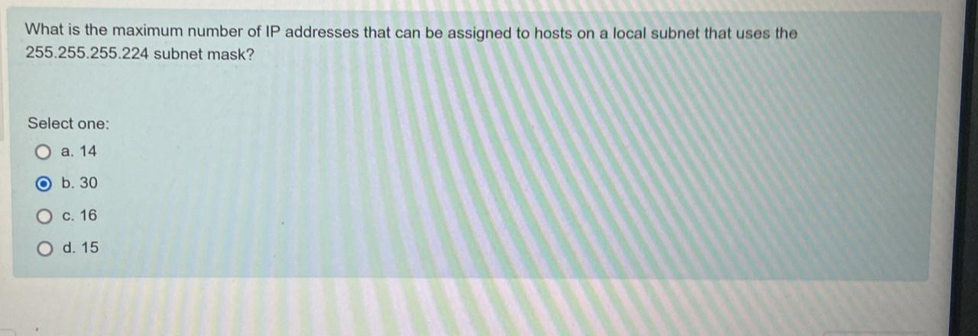

B:30

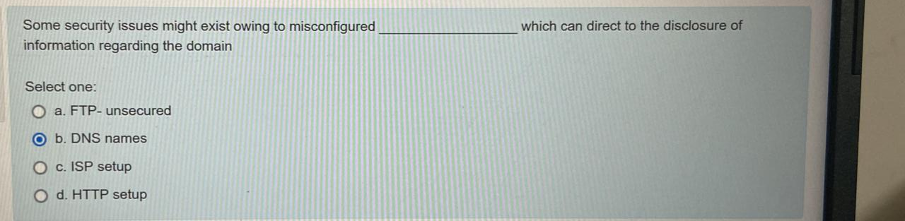

**B:DNS names**

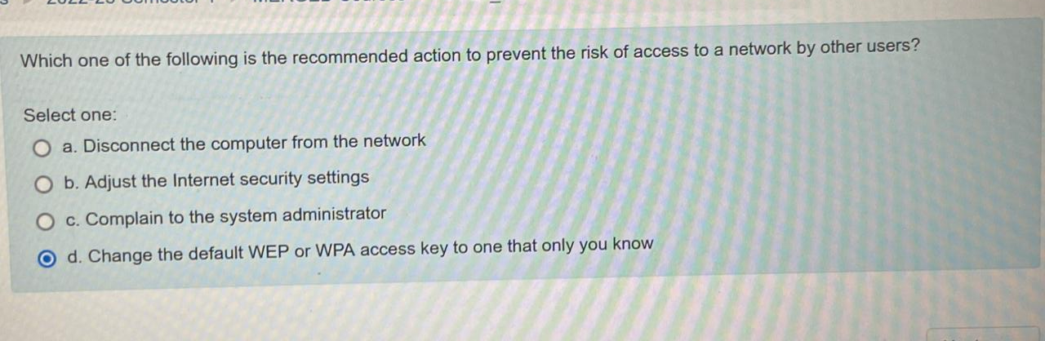

Adjust the Internet security settings.​

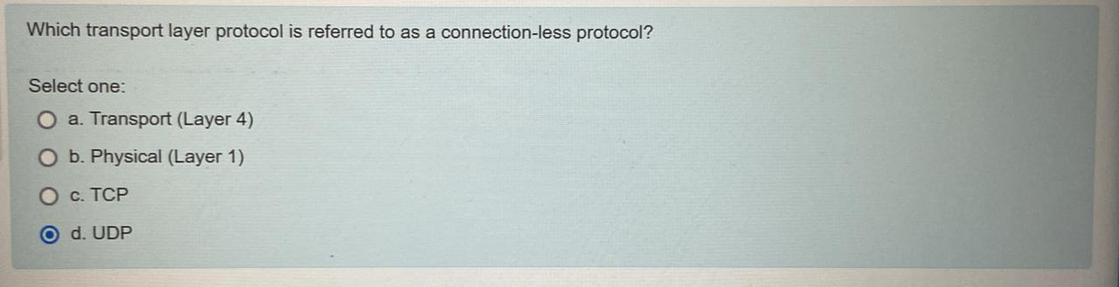

UDP

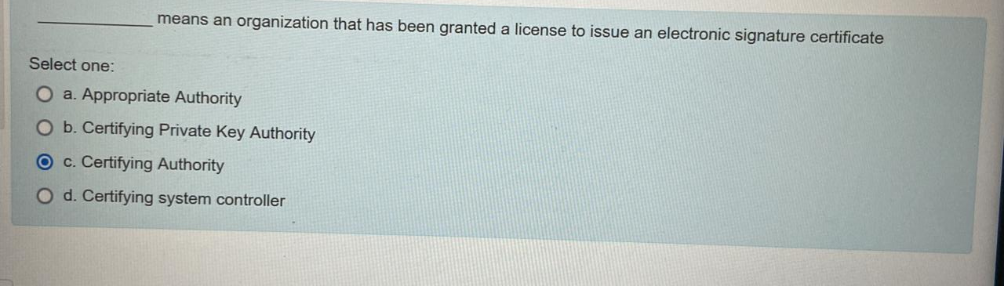

A. Certifying Authority

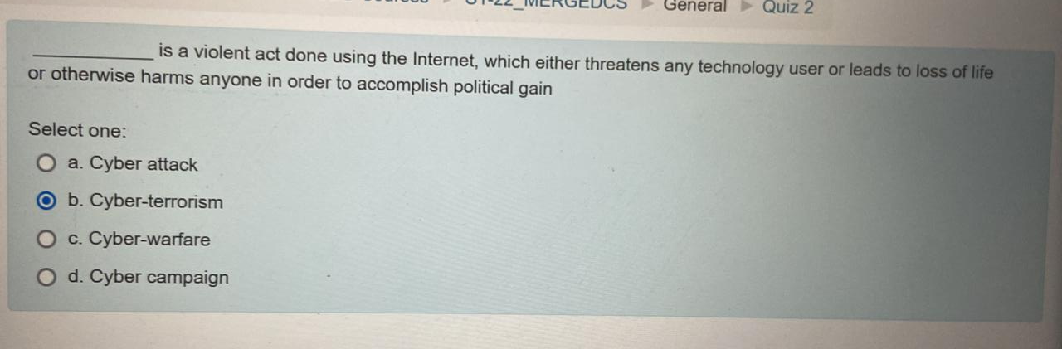

**Cyberterrorism**

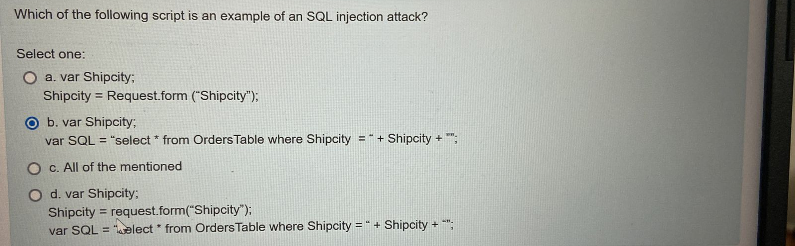

var Shipcity;

ShipCity = Request.form ("ShipCity");

var **SQL** = "select * from OrdersTable where ShipCity = '" + ShipCity + "'";

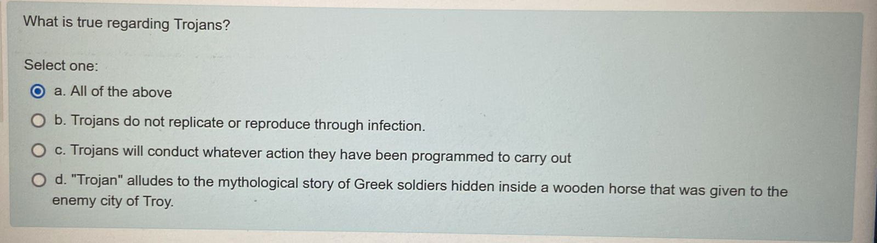

 All of the above statement are true.

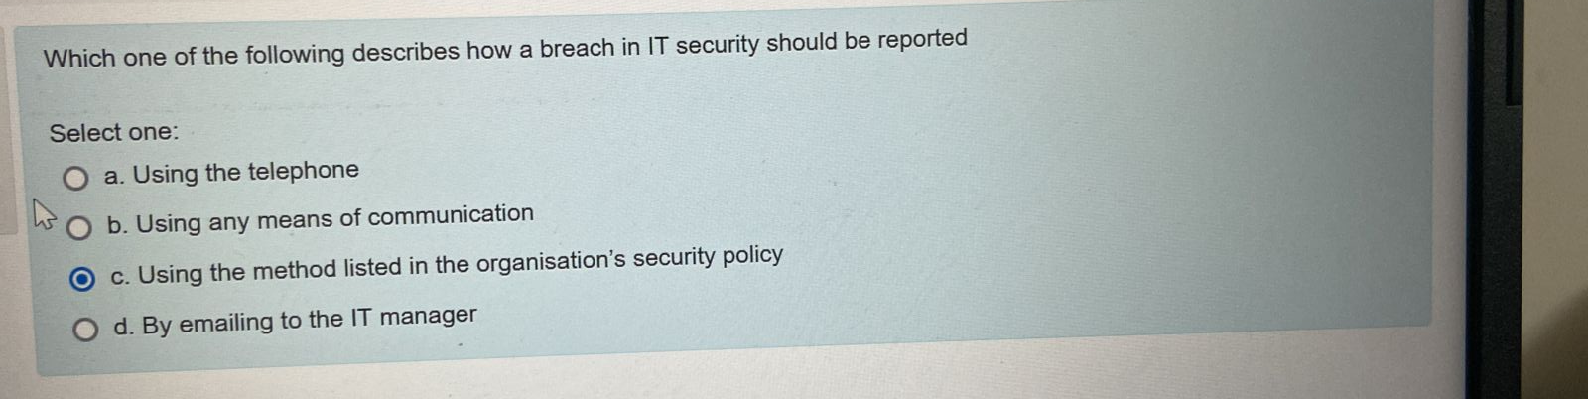

Ans :c

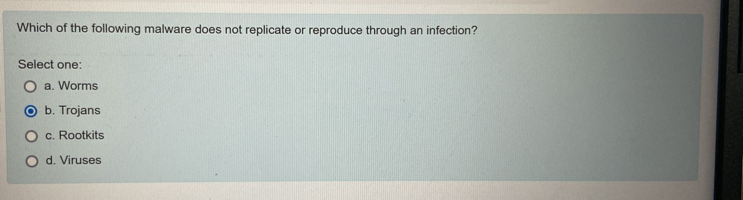

**Trojans**

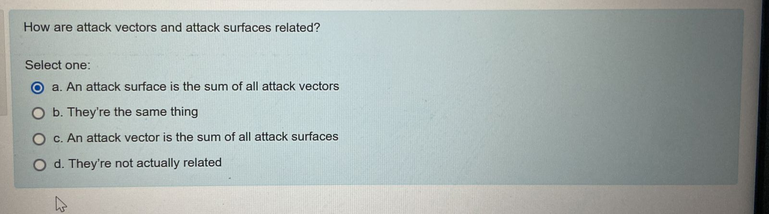

An attack surface is the sum of all attack vectors.

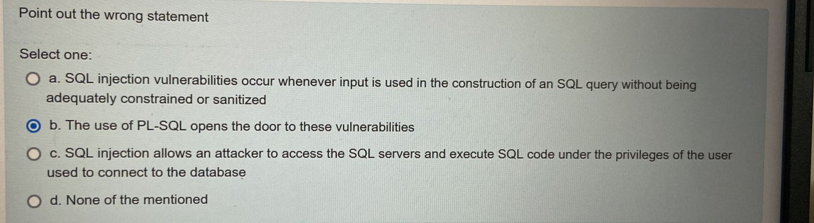

The use of PL-SQL opens the door to these vulnerabilities